How to draw chart in your Django page?

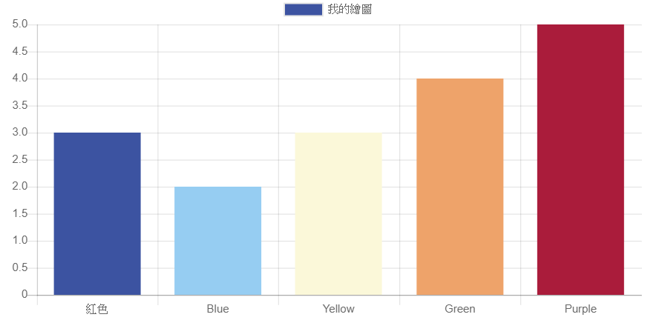

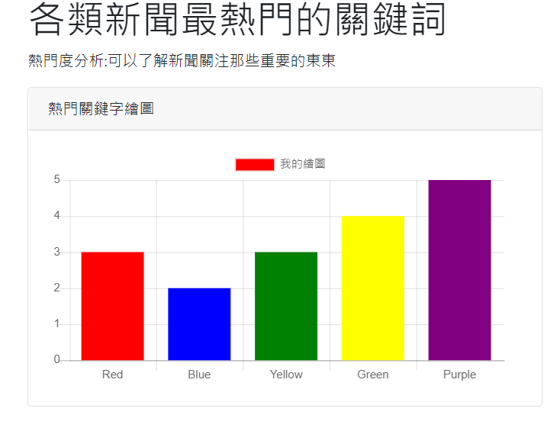

There are many other chart libraries you can use, such as [D3.js](https://d3js.org/) and [Highcharts](http://www.highcharts.com/)

Here, we draw bar chart using Char.js.

Development tools

PyCharm, Sublime, Atom, Notepad++, vi, vim, VS code

In this class, we use VScode or PyCharm.

Create a new Django project

Project Folder Name:

websit_news_analysis_v1

Create project inside project folder in the terminal:

django-admin startproject **website_configs .**

Create an app

The next step is to create your app.

App name:

app_top_keyword

Create app in the terminal:

python manage.py startapp app_top_keyword

settings.py

settings.py

|  |
| --- |
| ALLOWED_HOSTS = ['localhost', '127.0.0.1']  INSTALLED_APPS = [  …..  'app_top_keyword',  ] |

urls.py

website_configs/urls.py

|  |
| --- |
| from django.urls import path  from app_top_keyword import views  urlpatterns = [  path('topkeys/', views.draw_barchart),  ] |

views.py

views.py

|  |
| --- |
| from django.shortcuts import render  def draw_barchart(request):  values = [3, 2, 3, 4, 5]  labels = ['實習', '學生', '故宮', '導覽', '科大']    response = {  "values": values,  "labels": labels  }  return render(request, 'app_top_keyword/chart_topword.html', {'chartdata': response}) |

HTML (Front end)

Create an html file “chart_topword.html” in the following folder:

app_top_keyword/templates/app_top_keyword/chart_topword.html

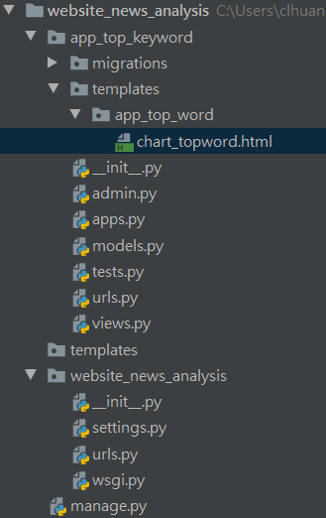

app_top_keyword/templates/app_top_keyword/chart_topword.html

|  |
| --- |
| <!DOCTYPE html>  <html lang="en">  <head>  <title>輿情分析平台</title>  <meta charset="utf-8">  <meta name="viewport" content="width=device-width, initial-scale=1">  <link rel="stylesheet" href="https://maxcdn.bootstrapcdn.com/bootstrap/4.3.1/css/bootstrap.min.css">  <script src="https://ajax.googleapis.com/ajax/libs/jquery/3.3.1/jquery.min.js"></script>  <script src="https://cdnjs.cloudflare.com/ajax/libs/popper.js/1.14.7/umd/popper.min.js"></script>  <script src="https://maxcdn.bootstrapcdn.com/bootstrap/4.3.1/js/bootstrap.min.js"></script>  </head>  <body>  <div class="container">  <div class="row">  <div class="col-lg-12">  <h1>各類新聞最熱門的關鍵詞</h1>  <p>熱門度分析:可以了解新聞關注那些重要的東東</p>  </div>  <!-- 繪圖區塊-->  <div class="col-lg-6 mb-5">  <div class="card">  <div class="card-header">  <h3 class="h6 text-uppercase mb-0">熱門關鍵字繪圖</h3>  </div>  <div class="card-body">  <canvas id="mychart"></canvas>  </div>  </div>  </div><!-- 區塊結束-->  </div> <!-- row結束-->  </div> <!-- container結束-->  </body>  </html>  <!-- jQuery指令用到的js-->  <script src="https://code.jquery.com/jquery-3.1.0.min.js"></script>  <!-- chartjs圖js-->  <script src="https://cdnjs.cloudflare.com/ajax/libs/Chart.js/2.7.3/Chart.min.js"></script>  <!-- 程式碼區 -->  <script>  //在前面html區域欲顯示的圖代號  let ctx1 = document.getElementById("mychart");    //讀取從views 傳送過來的繪圖資料  //並指定給兩個變數values, labels  let chartdata = {{ chartdata | safe }};  //印出訊息在瀏覽器的Console畫面  console.log(chartdata);  //產生一個圖物件 使用一次，因此不用給名稱(匿名即可)  new Chart(ctx1, {  type: 'bar',  data:  {  labels: chartdata.labels,  datasets: [{  label: '我的繪圖',  data: chartdata.values,  backgroundColor: ['red', 'blue', 'green', 'yellow', 'purple'],  }]  }, //data  options:  {  scales: {  yAxes: [{  ticks: {  beginAtZero: true  }  }]  },  }, //options  }); // chart  </script> |

How to get response data in front end template?

{{ chartdata }}

{{ chartdata | safe }}

let chartdata = {{ chartdata | safe }};

“safe” means to disable automatic HTML escaping

* get values

chartdata.values

or

chartdata['values']

* get labels

chartdata.labels

or

chartdata['labels']

Why do we use “|safe”?

**Django 的 Templates 有提供防護 XSS 的方法**

Django 事先想到了這一點，所以 Django 提出了一個 automatic HTML escaping，像是 < 會被轉成 &lt;，而 > 會被轉成 &gt;，' 會被轉成 &#x27;，" 會被轉成 &quot;，& 會被轉成 &amp;。

這些轉換都是 Django 預設的，也就是說，就算你不知道 Django 有 automatic HTML escaping 的機制，你還是會受到保護，防止惡意的 injection。

如果你在某些欄位要關掉這一層的防護機制，只要加上 |safe 就可以關掉 escaping。

Source: https://ithelp.ithome.com.tw/articles/10230384

How to get the document element using JavaScript?

"mychart" is the attribute value of canvas id

“mychart” is the bar chart id

<div class="card-body">

<canvas id="mychart"></canvas>

</div>

ctx1 is the bar chart variable in JS

let ctx1 = document.getElementById("mychart");

How to draw bar chart using JavaScript?

|  |
| --- |
| //create a chart  new Chart(ctx1, {  type: 'bar',  data:  {  labels: chartdata.labels,  datasets: [{  label: 'My Bar Chart',  data: chartdata.values,  backgroundColor: ['red', 'blue', 'green', 'yellow', 'purple'],  }]  }, //data  options:  {  scales: {  yAxes: [{  ticks: {  beginAtZero: true  }  }]  },  }, //options  }); // chart |

Strat server

python manage.py runserver 8000

http://localhost:8000

What is Chart.js

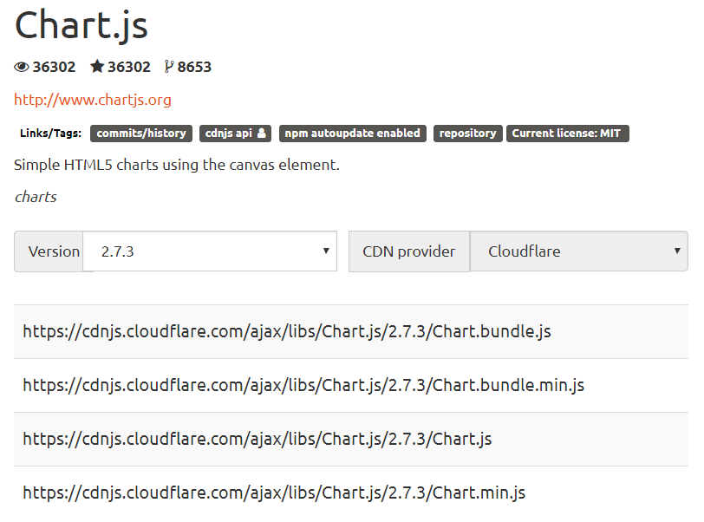

<https://cdnjs.com/libraries/Chart.js>

Official demonstration for various charts:

<https://www.chartjs.org/samples/latest/>

How to load Chart.js in an html?

<script src="https://cdnjs.cloudflare.com/ajax/libs/Chart.js/2.7.3/Chart.min.js"></script>

Load jQuery

<script src="https://code.jquery.com/jquery-3.1.0.min.js"></script>

Here is a bar chart example:

Creating a Chart

To create a chart, we need to instantiate the Chart class. To do this, we need to pass in the node, jQuery instance, or 2d context of the canvas of where we want to draw the chart.

Here's an example.

|  |
| --- |
| <canvas id="myChart" width="400" height="400"></canvas>  // Any of the following formats may be used  var ctx = document.getElementById("myChart");  var ctx = document.getElementById("myChart").getContext("2d");  var ctx = $("#myChart");  var ctx = "myChart";  Once you have the element or context, you're ready to instantiate a pre-defined chart-type or create your own!  The following example instantiates a bar chart showing the number of votes for different colors and the y-axis starting at 0.  Here is the bar chart tag:  <canvas id="myChart" width="400" height="400"></canvas>  Here is the javascript:  <script>  var ctx = document.getElementById("myChart");  var myChart = new Chart(ctx, {  type: 'bar',  data: {  labels: ["Red", "Blue", "Yellow", "Green", "Purple", "Orange"],  datasets: [{  label: '# of Votes',  data: [12, 19, 3, 5, 2, 3],  backgroundColor: [  'rgba(255, 99, 132, 0.2)',  'rgba(54, 162, 235, 0.2)',  'rgba(255, 206, 86, 0.2)',  'rgba(75, 192, 192, 0.2)',  'rgba(153, 102, 255, 0.2)',  'rgba(255, 159, 64, 0.2)'  ],  borderColor: [  'rgba(255,99,132,1)',  'rgba(54, 162, 235, 1)',  'rgba(255, 206, 86, 1)',  'rgba(75, 192, 192, 1)',  'rgba(153, 102, 255, 1)',  'rgba(255, 159, 64, 1)'  ],  borderWidth: 1  }]  },  options: {  scales: {  yAxes: [{  ticks: {  beginAtZero:true  }  }]  }  }  });  </script> |

<https://www.chartjs.org/docs/latest/getting-started/usage.html>